**Homework 1**

***Question 1- Answers:***

1. 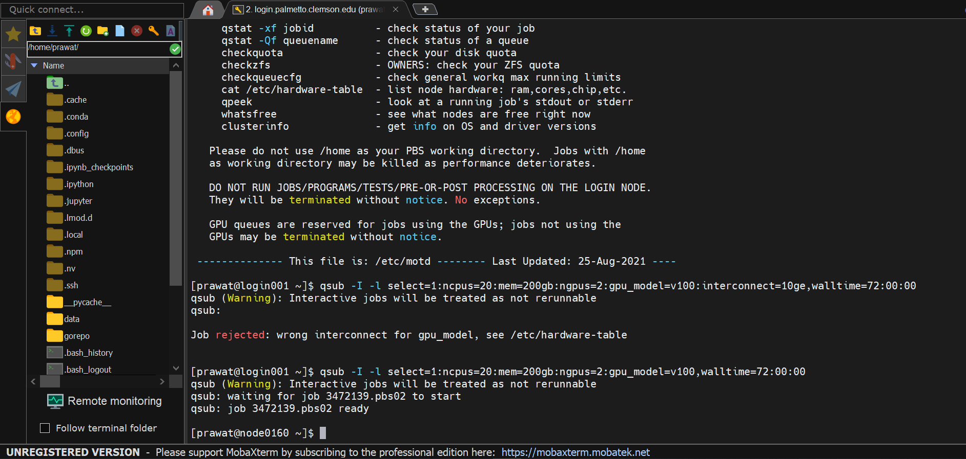**Show screenshots of successful installation and procedure of the setup. (15 points)**

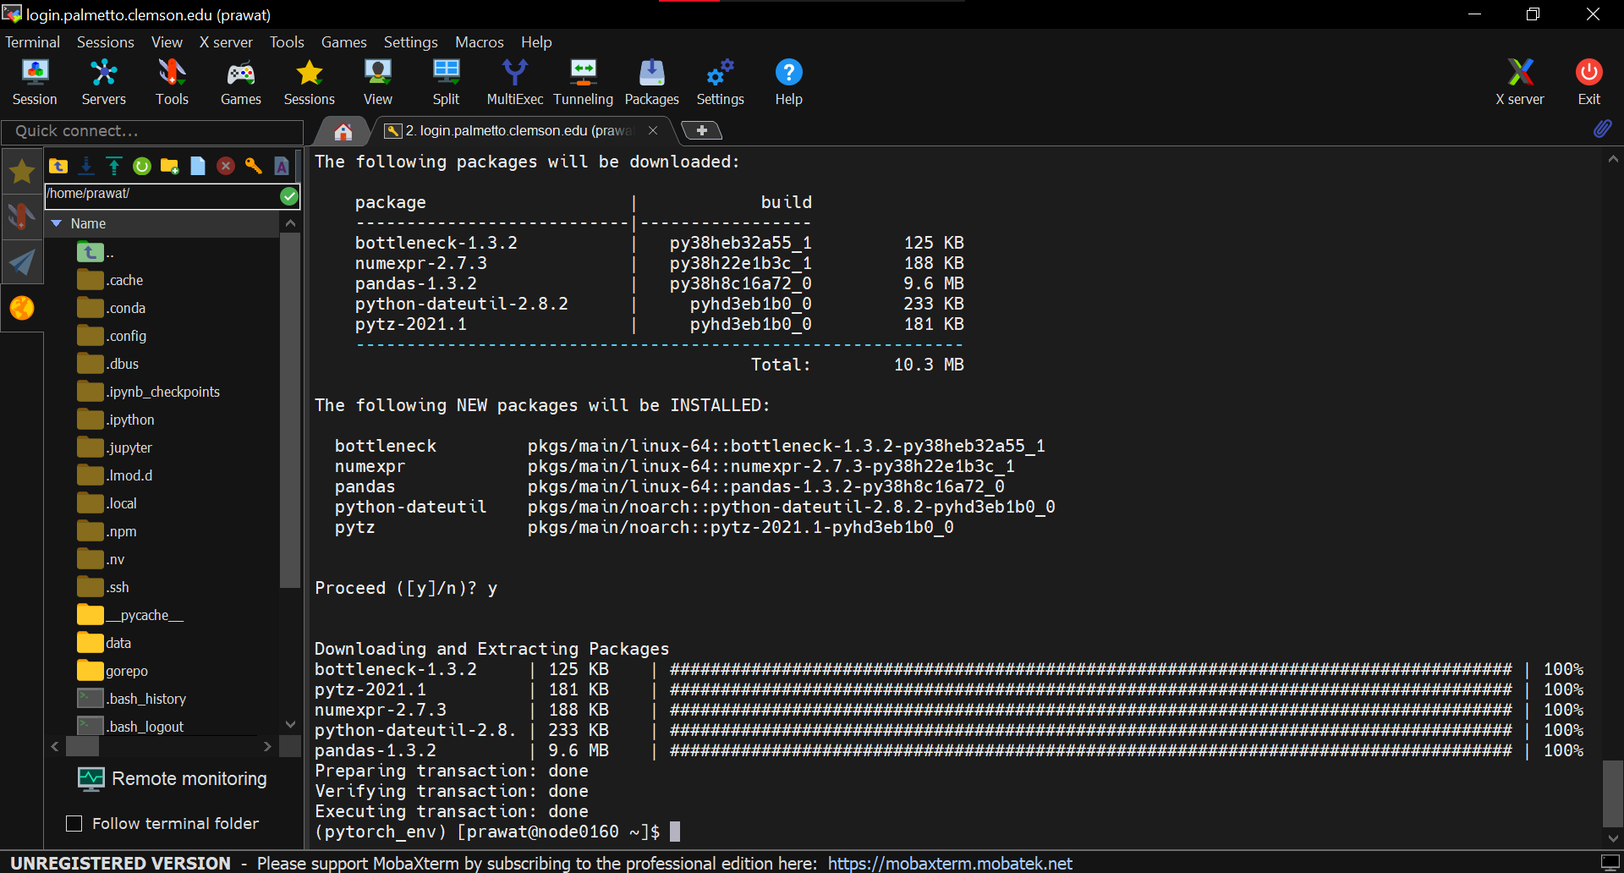

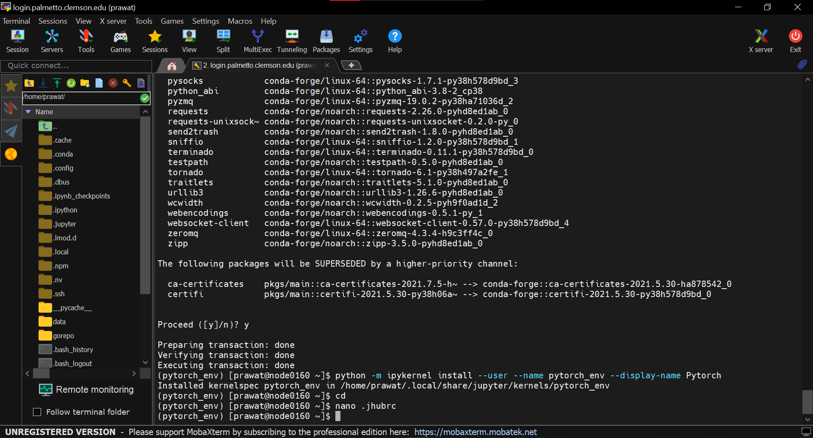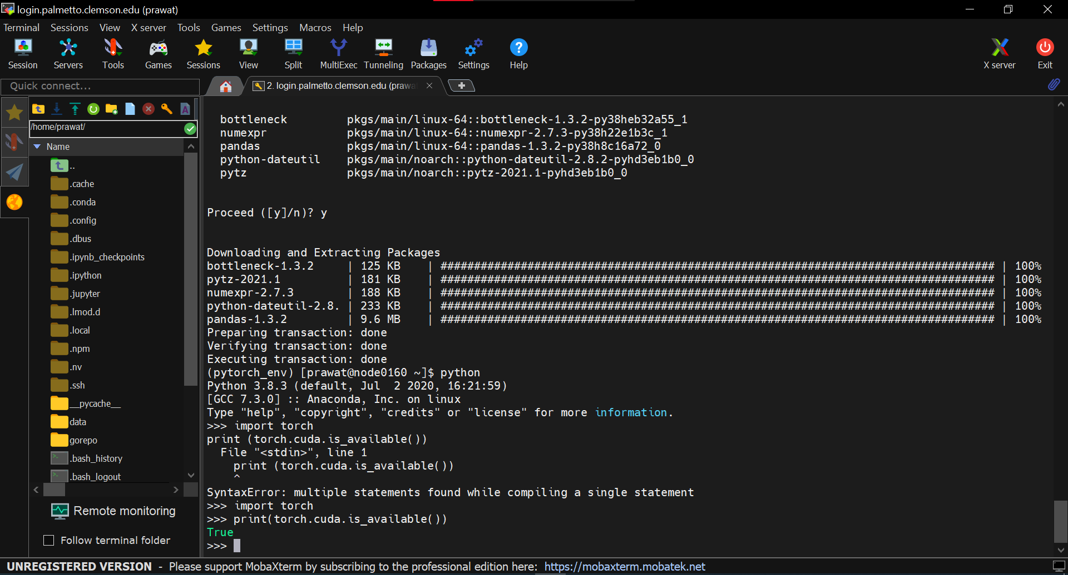

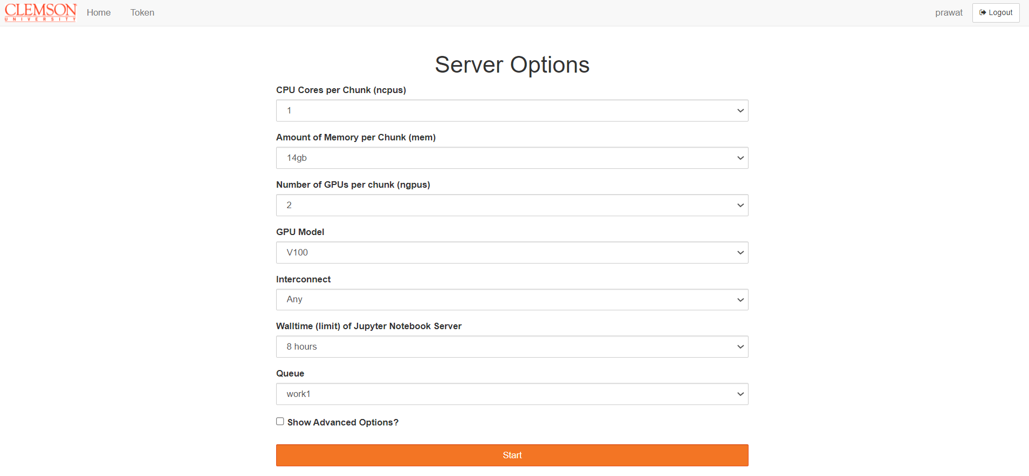

**(2) Run the existing sample code “base.ipynb” (5 points)**

**During the training, what’s your GPU usage percentage? (You can open another terminal and use “nvidia-smi –l” to monitor the usage info of GPU and GPU memory.)**

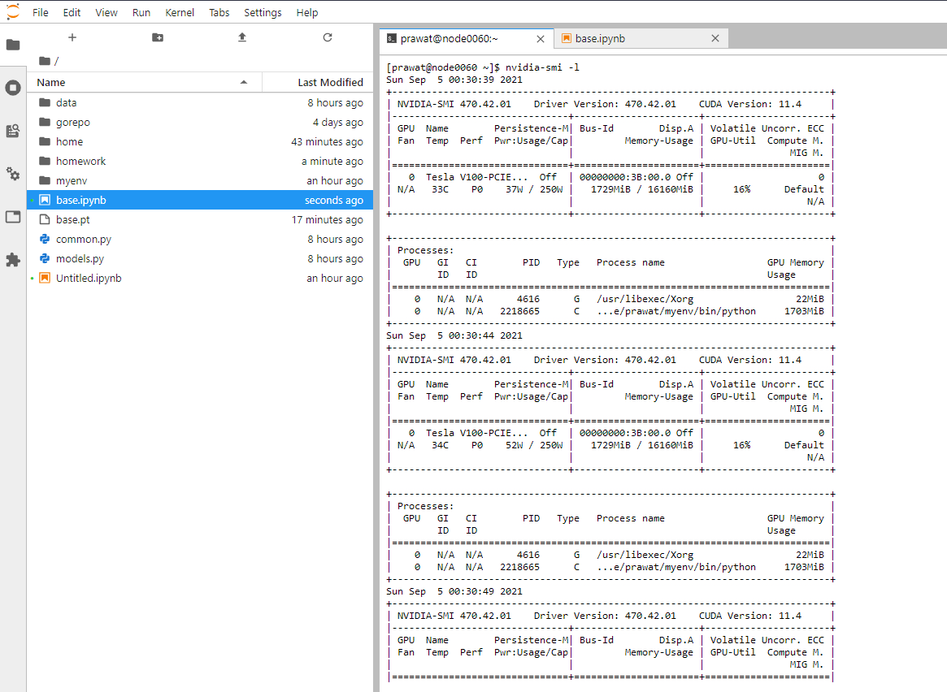

**(3) Modify the code for better performance (change the batch size) (10 points)**

**During the training, what’s your GPU usage percentage?**

* I took the batch size = 8, and during training my GPU usage percentage increased to about 29%.

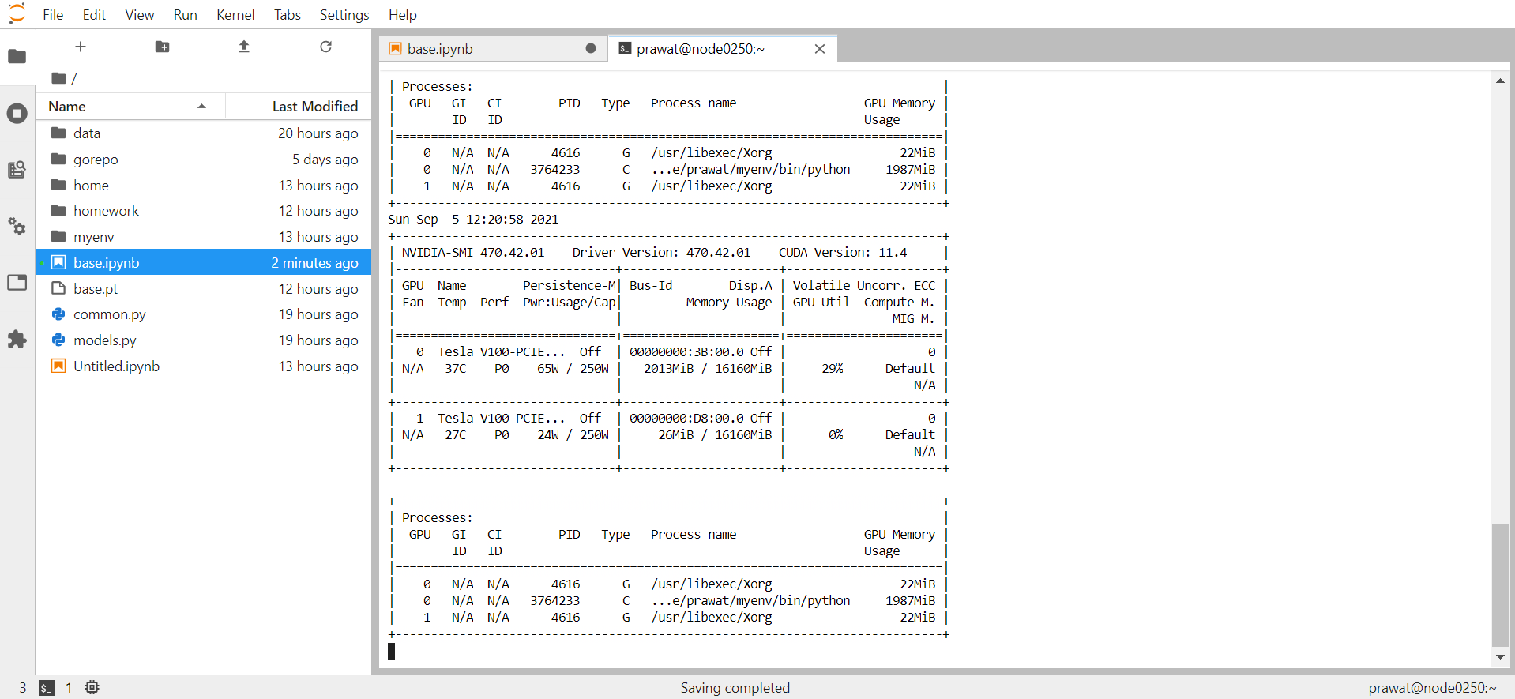

**(4) Modify the code for better performance (use two GPUs) (10 points)**

**During the training, what’s your GPU info percentage? (TIPS:**[**reference API**](https://pytorch.org/tutorials/beginner/former_torchies/parallelism_tutorial.html)**)**

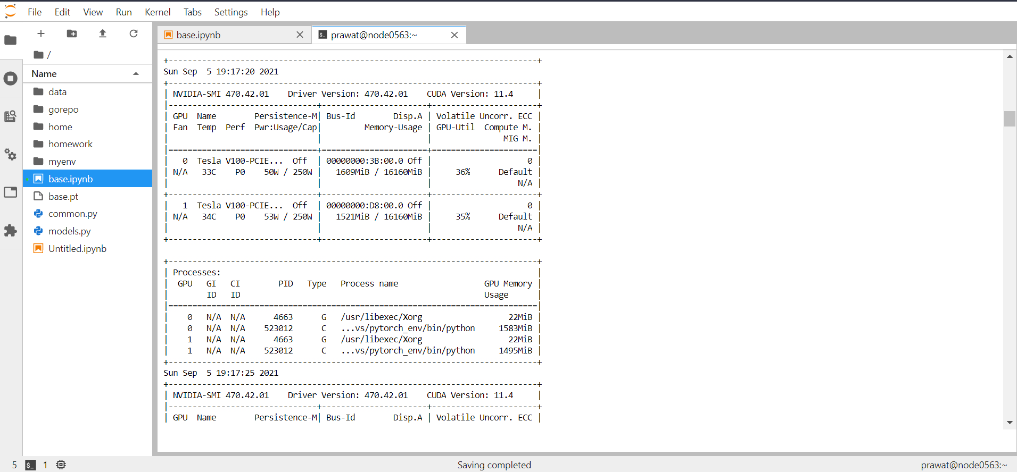

**(5) Plot the accuracy against the number of training Epochs on a Graph. (10 points)**

**(TIPS: you need to import matplotlib, modify the code of “for epoch in range (EPOCHS):” by saving the “epoch” and “train_acc”, and plot its relationship in the end)**

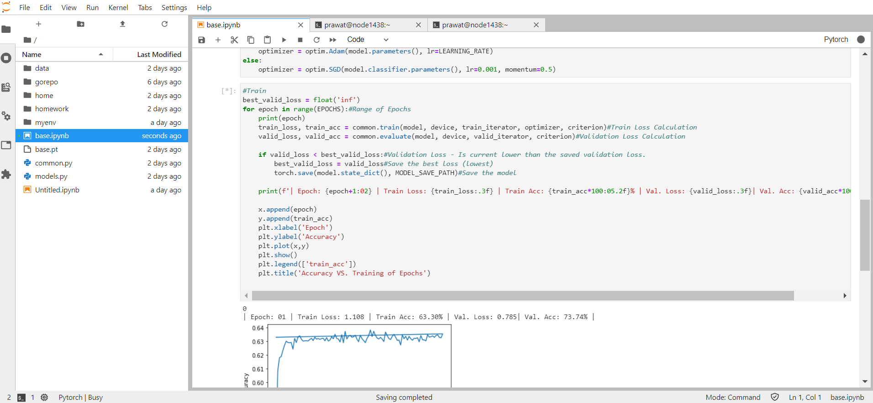

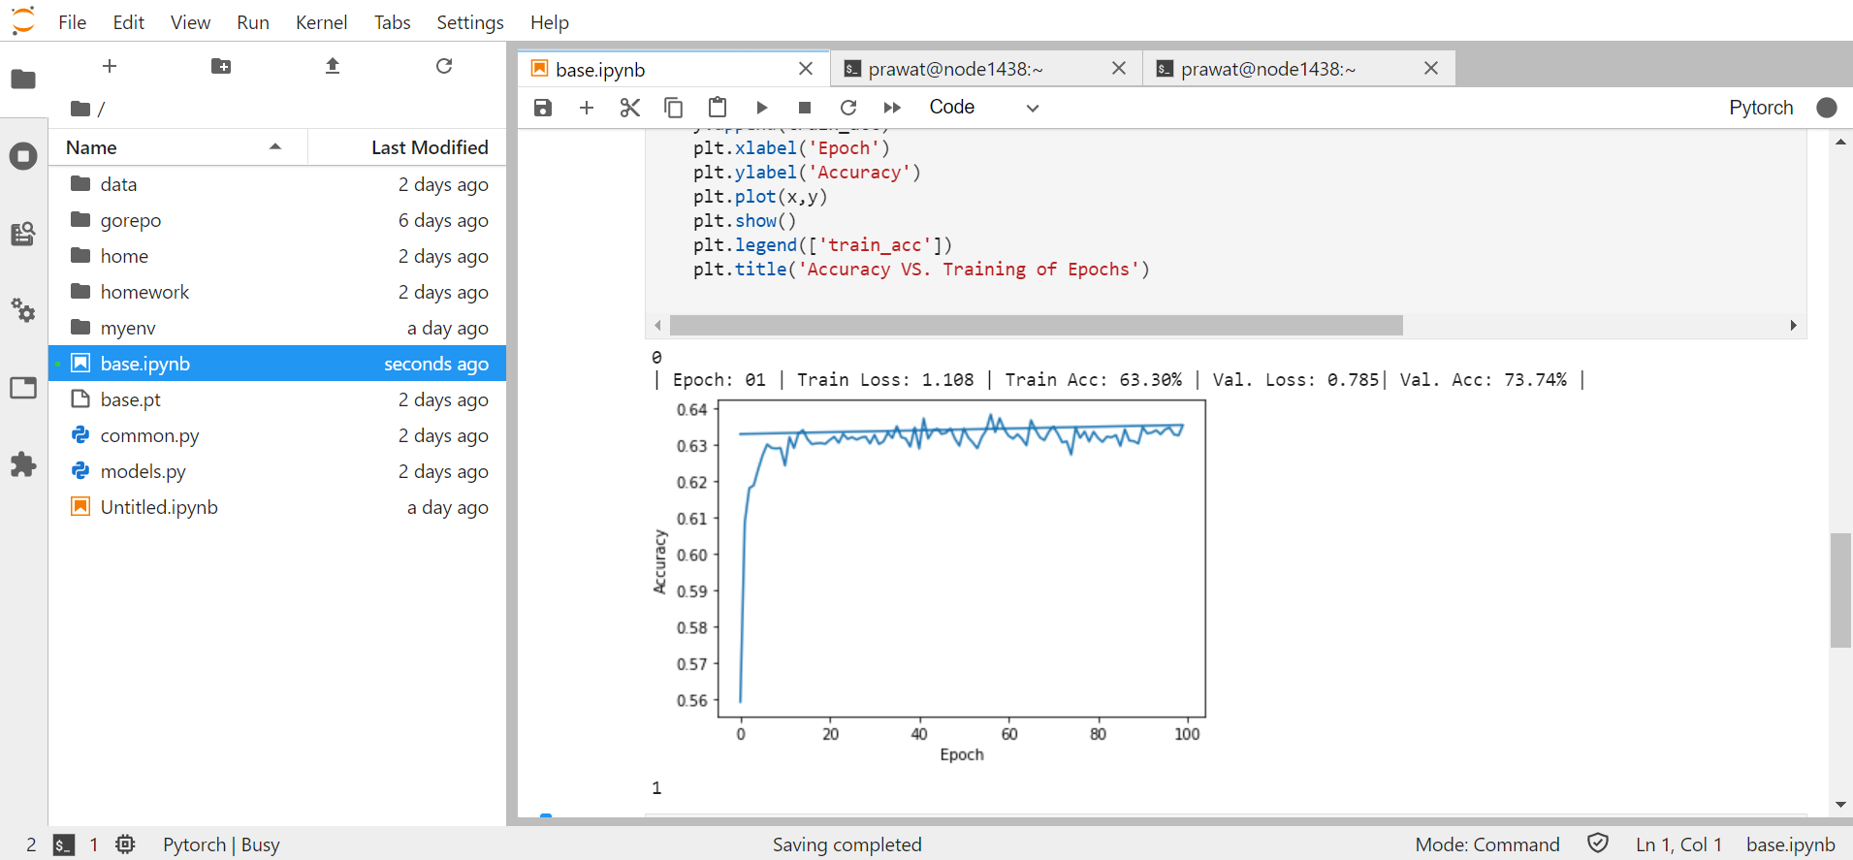

**(7) Perform a model inference for a certain image, which you can choose from anywhere. The image shall include the object which belongs to the category of the training dataset. (10 points) (TIPS: if you are using CIFAR10 datasets, its categories are shown in this reference)**

